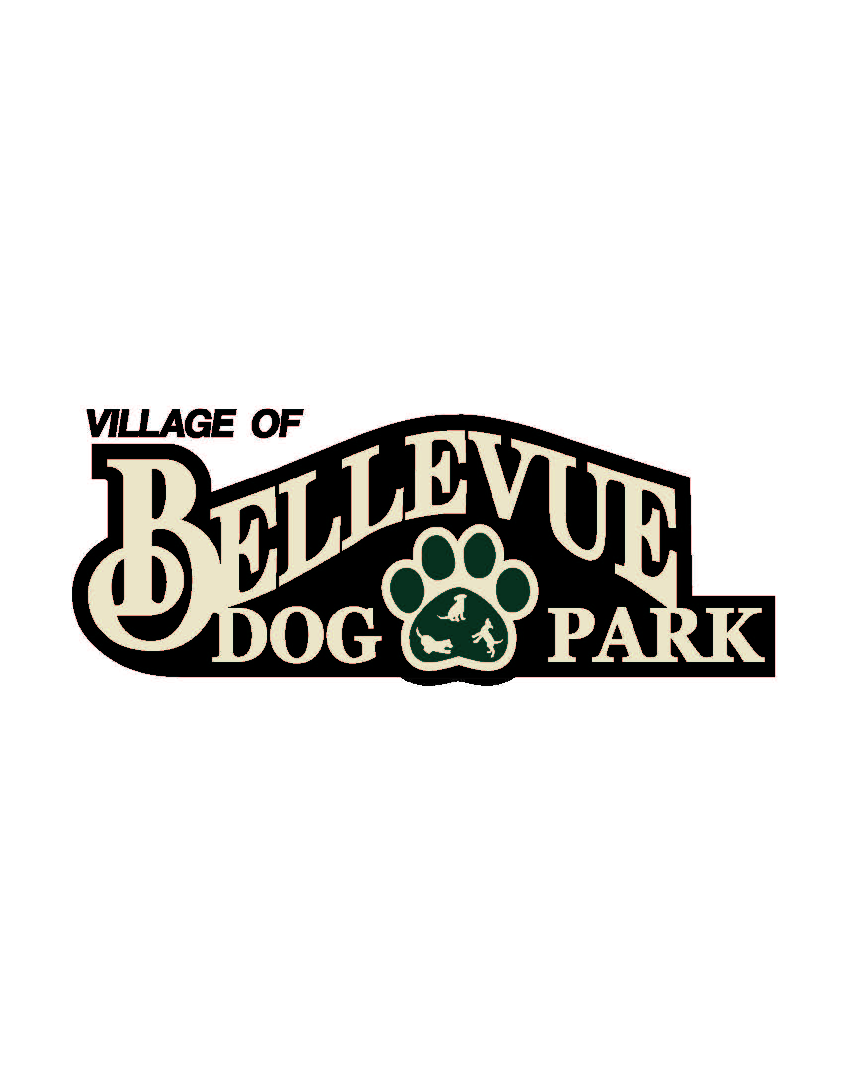
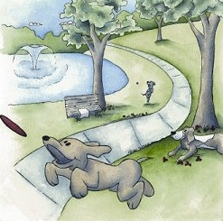

Laura & Peter Mossakowski
Family Dog Park

Minutes
November 14, 2014
12:30 pm @ Village Hall / Public Safety Building; 3100 Eaton Road

- Welcome & Introductions: Committee Members in attendance were: Steve Soukup, Paul Adkins, Matt Hahn, Deb Lom, Alex Boulanger, Laura Mossakowski, Paul Theys, Angela Gorral, Mark Taggart, Gayle Grier, Sandy Kemper
- Approval of Minutes: Steve Soukup and Mark Taggart make a motion
- Capital Fundraising Campaigns
  - Fund Balance – Recent Donations Update: $37,203.59
  - Major Campaign Updates: Steve is working to campaign the park as equally good for human health as pets and working on the path connection.
  - Community Campaign Updates
    - Collection Box Inventory Update - none
    - Paw Print Sales – $45
    - Basket Raffles/Other- $246
- Grants/Foundation Updates- Alex is applying for grants. Schrieber foundation ($10,000) and Shopko foundation and Green Bay foundation. Matt applied for associated. Deb is working on BMO.
- Other Matters: Paul Adkins proposed that we advertised more and put up signs to help our fundraising. It is up to village if we can put up a sign. Funding would also be difficult. Schmidt Park has a lot of dog owners that would be interested in our park. Cats Anonymous brought in $10,000 at their silent auction. This is something to think about. Our facebook page has really grown. That helps get the word out. Amazon smile works like the Ebay donation page. We could sign up for that too and get more donations. The board approved the nondiscrimination Policy.
- Next Meeting: December 12, 2014
- Laura Mossakowski and Mark Taggart motion to adjourn at 1:29 pm

