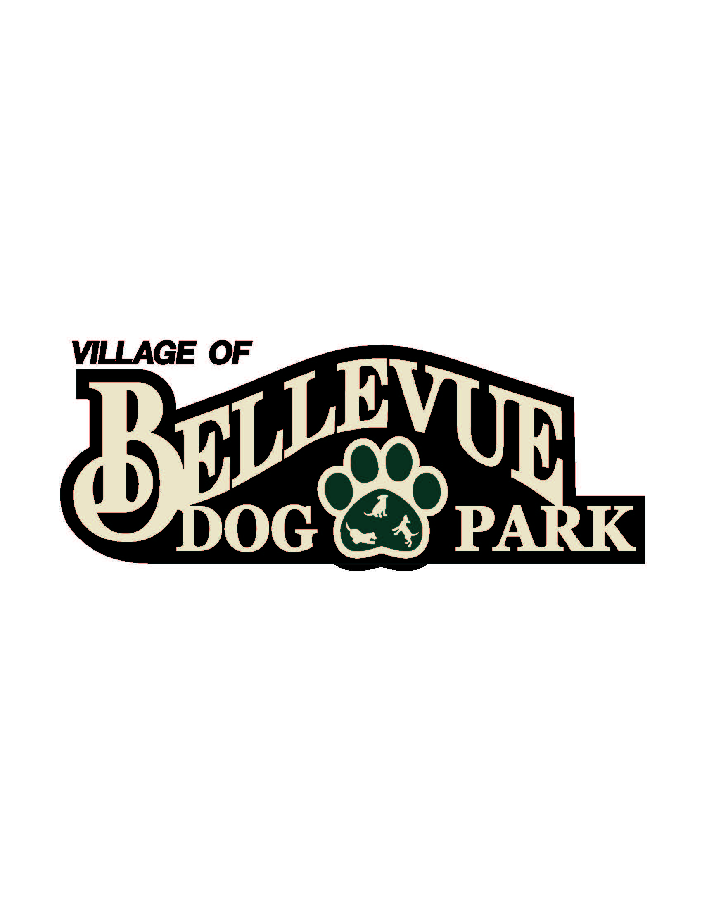
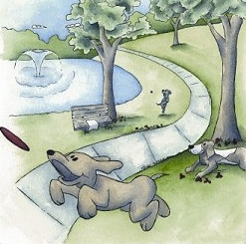

Laura & Peter Mossakowski
Family Dog Park

AGENDA
May 8, 2015
12:30 pm @ Josten Park
Meeting Topics:

- Welcome & Introductions
- Approval of Minutes
- Set up baskets and park for k-9 karnival
- Next Meeting: TBD

