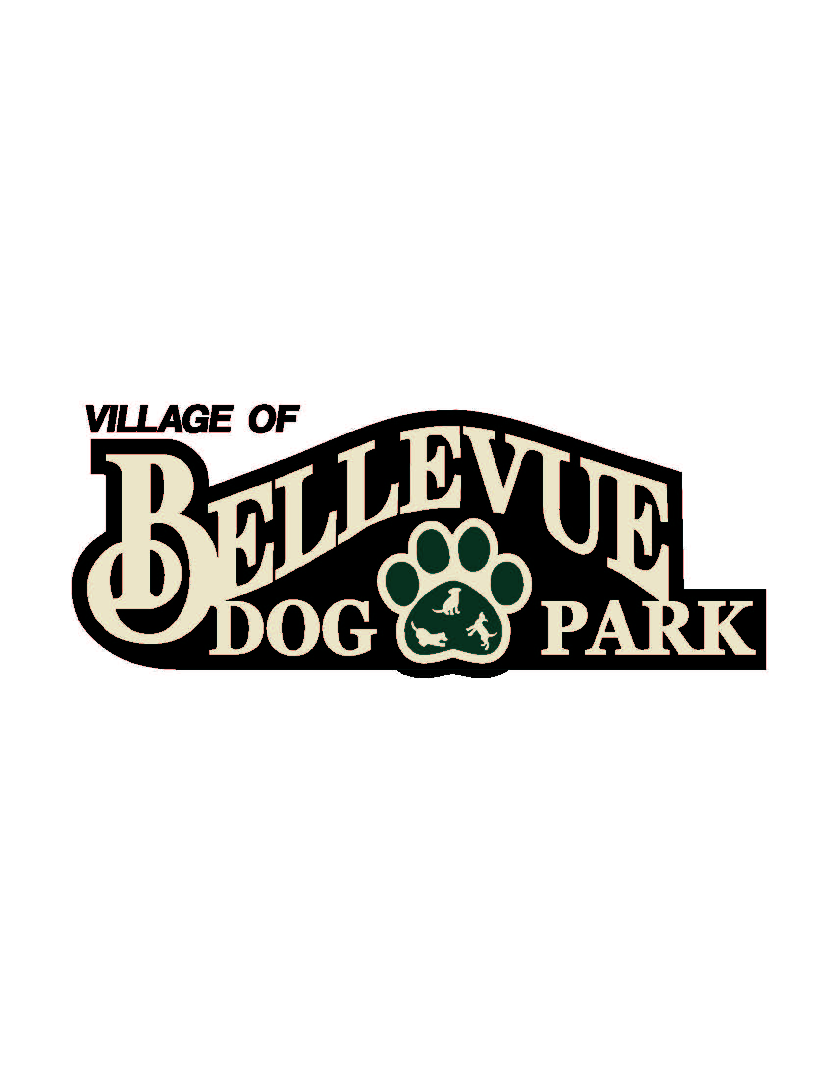
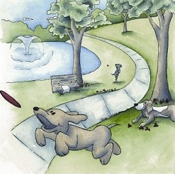

Laura & Peter Mossakowski
Family Dog Park

MINUTES
April 17, 2014
12:30 pm @ Bellevue Public Service Building
- Welcome & Introductions: Committee members in attendance were Laura and Pete Mossakowski, Matt Hahn, Paul Theys, Sandy Kemper, Steve Soukup, Donn Foote

- Approval of Minutes: Motion by Laura Mossakowski, second Sandy Kemper to approve the January 2014 minutes as presented. Motion carried unanimously.

- K-9 Karnival Planning (Saturday, May 9): We would like a sign in the front of the event with donation boxes. Discussed raffle and if we want to announce them all at one time or space them out throughout the day. Discussed the venders, their locations, and what they need. Discussed everyone’s duties and their responsibilities. Discussed number of tickets to play games. 3 for bounce house, 4 for lure course. Will meet day before event to set up baskets and park.

- Capital Fundraising Campaigns
  - Fund Balance – Recent Donations Update: Theys provided an update on the fundraising account noting that the total is now at $49,81.17
  - Major Campaign Updates: No major campaign updates were provided.
  - Community Campaign Updates: none
    - Collection Box Inventory $108
    - Paw Print Sales: none
    - Basket Raffles/Other: none
  - Grants/Foundation Updates: none

- Next Meeting: The next meeting of the Dog Park Committee was set for Friday, May 8, at 12:30 p.m. at Josten Park

