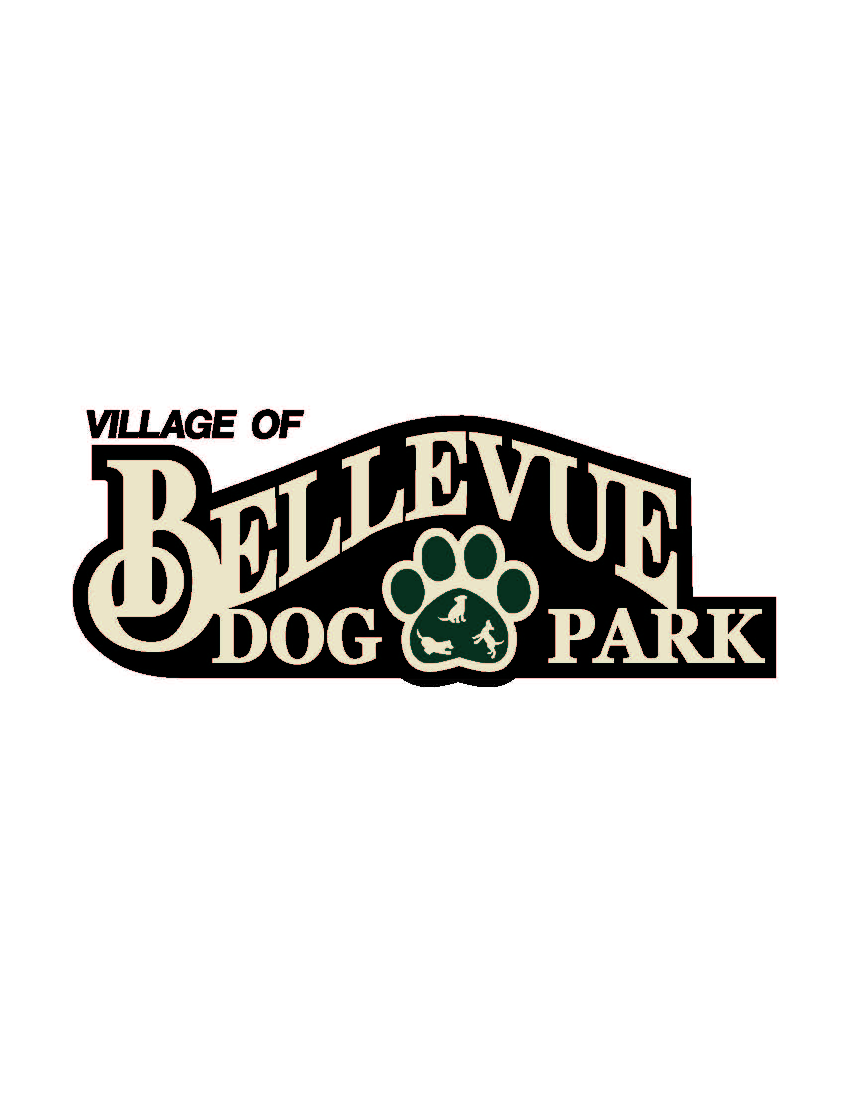
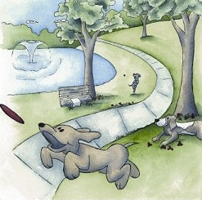

Laura & Peter Mossakowski
Family Dog Park

AGENDA
June 5, 2015
12:30 pm @ Village Hall / Public Safety Building; 3100 Eaton Road
Meeting Topics:

- Welcome & Introductions

- Approval of Minutes
- Next steps to be taken
-Agreement between village and committee
-Goals/What is our vision
-Necessary items for Phase 1 of Dog Park and Budget
-Construction layout, ordinances, codes, permits, phases, etc
-Fencing

- Sponsorships
- PetSafe Contest – Keep Voting! And rules if we are selected as a finalist
- Capital Fundraising Campaigns
  - Fund Balance – Recent Donations Update
  - Major Campaign Updates
  - Community Campaign Updates
    - Collection Box Inventory Update
    - Paw Print Sales
    - Basket Raffles/Other
  - Grants/Foundation Updates

- Other Matters
- Next Meeting: TBD

