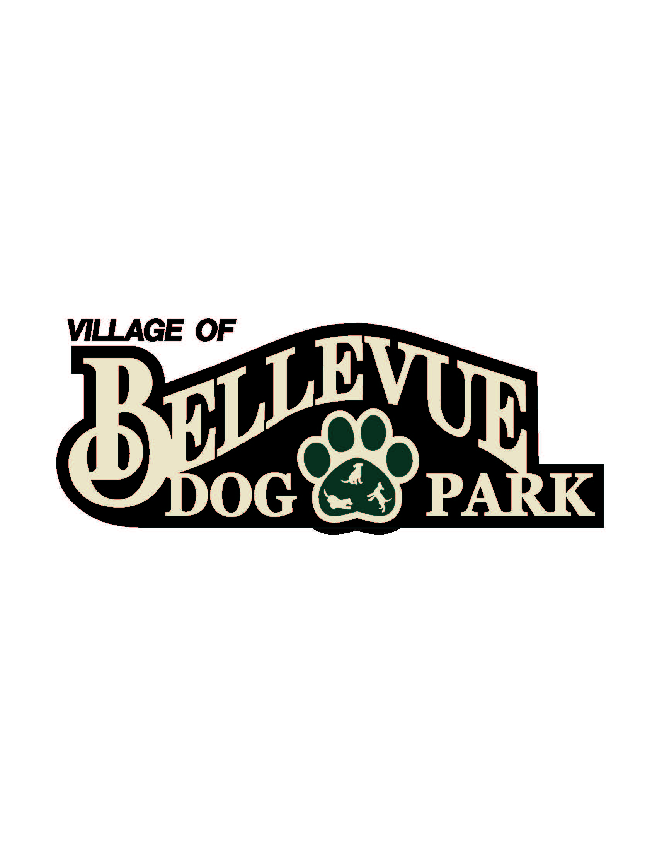
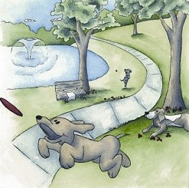

Laura & Peter Mossakowski
Family Dog Park

Minutes
June 6, 2014
12:30 pm @ Village Hall / Public Safety Building; 3100 Eaton Road

- Welcome & Introductions: Committee Members in attendance were: Sandy Kemper, Shawn Schneider, Laura Mossakowski, Paul Theys, Steve Soukup, Kaitlyn Soukup, Debra Lom
- Approval of Minutes: Sandy Kemper and Paul Theys
- 501(c)(3) Designation – May 15 it was submitted. They have 90 days to get back to us. Hoping for sooner.
- K-9 Karnival feedback (Saturday, May 10). – A lot of people wanted us to raffle off at one time, at the end of the raffle. Laura says to let numbers talk and compare the numbers from last year to see which way makes most sense. Put up signs next year for where venders should go. Expand the registration booths, too busy and couldn’t tell everyone all the details. Lure course and bounce house didn’t have signs for how many tickets. More activities for dogs. Lots of people looking for water for dogs; have a water station. More rounded Lure course. Continuous direction over speaker. Have picnic tables by lure course to watch. 121 groups sign in. 2-4 humans per dog. Deb said Matt and her talked about putting together assignments for putting everything together to prevent confusion. Bake sale went over really well. Deb received additional checks from GBAEC and Forever Friends. Total made with sponsors and cash: $3750
  - Stick with the K rather than C in “Karnival”. Have a lot of signage that is spelt that way and makes it unique.

- Dog walk feedback- 24 dogs, made $220 at the walk; Globe matched it for a total of $440. Want to have future walks in fall rather than spring. Re-do the route, too busy.
- Movie In the Park (Friday, August 1). Later in the evening, so have more snacky stuff since people will have eaten dinner. Happy Joes? 56 slices in on oven. We won’t be out of money for it, they pick up what wasn’t eaten. Deb asked how we wanted to buy stuff, have Paul go and/or Deb and have us reimburse them. Paul thought it would be easier to reimburse them. Need to bring coolers. Sandy thought she had two people form OVVH, needs to confirm. Need volunteers for dog check-in and concessions. Matt and Deb will handle to movie. $5 suggested donation.
- Capital Fundraising Campaigns
  - Fund Balance – Recent Donations Update: $33,789.93
  - Major Campaign Updates: waiting for 501c3
  - Community Campaign Updates
    - Collection Box Inventory Update - none
    - Paw Print Sales –none
    - Basket Raffles/Other- none
    - Grants/Foundation Updates: none
- Other Matters: Laura proposed signing up for square reader for taking donations when people don’t have cash. Also, signing up for Survey Monkey, you get 50 cents/ completed survey. Goes to charity of choice. Laura asked when we could start talking about breaking ground. She said she could give another contribution to help it move forward. We need to get Bellevue Board to officially set aside the land for us. Steve thinks next spring we will be able to really start moving forward. We are proposed, not dedicated. We need to get that changed before we can break ground. Deb thinks we should just get to the 60 thousand and then bring it to the board.
- Next Meeting: July 11, 2014
- Laura Mossakowski motions to adjourn at 1:45pm

