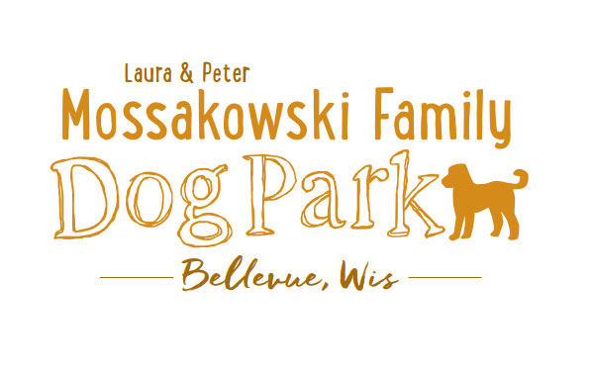
Agenda for 10/19:
Bellevue Dog Park Meeting
October 19, 2016
12:00-1:00pm
3100 Eaton Road

Meeting began:
In Attendance:
Secretary Report:
Approval of September 28th meeting minutes:
Treasurer report: Account Balance:
Community Fundraising:
Next meeting: Oct. 29th (work day at the park), Nov. 8th (TUESDAY) 12:30-2pm @ Laura's office
New Business:
Volunteer opportunities -
Work Day Task List -
Work Day Supply List
Next steps:
Meeting adjourned:

