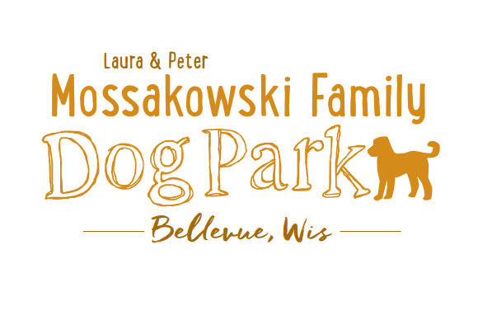
Laura and Peter Mossakowski Family Dog Park, LTD Committee Meeting
Date & Location: March 1, 2017 9:30am-11:30am; at Laura Mossakowski LLC (2555 Continental Dr.; Green Bay, 54311)
Meeting Began:
In attendance:
Secretary Report:
Approval of February’s minutes
Treasurers Report:
Current Balance:
Outstanding Bills:
Incoming Donations:
Community Fundraising:
K9 Karnival and Grand Opening major projects at this time
Grant Writing
Old Business:
Membership Stickers Ordered – sales start at K9 Karnival
Volunteer Committee Updates:
K9 Karnival Planning: (May 13th from 10am-2pm)
Raffle items / list of donors -
Volunteer Table added to Karnival Layout - include "titles/roles" that are needed (Grant writers, etc.)
MC - Alexi
Poss. Live Music
Booth coordination – Sandy
Station for credit card for Paul to be at
Walkie-talkies for communication
Raffle workers - Paul, Laura, and one added
Pictures - Jennie
Volunteer Table - Nicole
Posters/Fliers – Stephanie
Bounce House?
Luer Course?

Vendor Booths – booths selling food/beverages
Grand Opening Planning: Date TBD (ideally within a few weeks of K9 Karnival)
Home Depot Employee Work Day - Landscaping is specialty for the projects, a Grant covers the cost of the items
Ideally a 1-day project, need to do a walk-through and
Looking to do project around sign and driveway and around the fence where the trash bins are

Donation Envelopes with tear-off -

Signs to be donated by Forever Friends - need quotes - Size requirements not outlined by Village Board (4'X4' for larger sign thought to be appropriate)
Recommendations for sizes from companies and other parks
Village to approve final draft prior to printing
Village uses Rent-a-Flash for signage
Village can purchase them and the cost can be reimbursed
Colors to be coordinated with what is used throughout the park areas

Nicole Virant nominated as Director of Marketing to the Dog Park Committee Board Feb. 1, 2017

Addition of a Mission Statement for the Park – further thoughts/approval
Laura & Peter Mossakowski Family Dog Park (Bellevue Dog Park) is a volunteer-based, non-profit501(c)(3) organization. The Bellevue Dog Park Committee is dedicated to providing an off-leash dog park where dogs and their owners/friends have a safe, well-maintained area for recreation and socialization.
The Bellevue Dog Park committee will also make it their focus to educate children about safe behavior around dogs to ensure a common goal of safety and fun for all.
The Bellevue Dog Park relies on local and private funding to continue growth and development of this off-leash dog park. The committee welcomes collaboration with residents, businesses, municipalities, and non-profit groups to work toward this common goal.

Obtain Bulletin Board with plexi-glass coverings

Next Meeting Dates:
No further VB meetings set for Dog Park related items
Next committee meeting:
Construction Updates:
Still looking for nature to tell us when the grass can be mowed to allow further planning for opening dates
New Business:
Wix Memorial Update
Marketing Recruitment Ideas - Social Media plugs for upcoming events and volunteer needs
Volunteer Agreement (Will there be age requirements?)
Logging options for hours for volunteering through the year - potential to earn discounts off of future passes, brunch etc. – Further Thoughts
Items for Pet Expo needed?
Meeting Adjourned:

Topics for Next Meeting:

