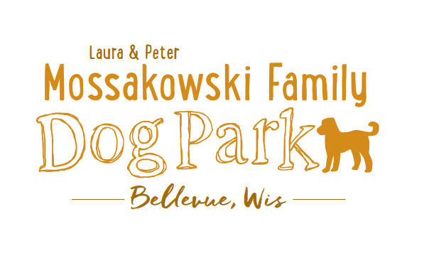
Laura and Peter Mossakowski Family Dog Park, LTD Committee Meeting
Date & Location: April 26, 2017 9:15am-11:15am; at Laura Mossakowski LLC (2555 Continental Dr.; Green Bay, 54311)
Meeting Began:
In attendance:
Secretary Report:
Approval of April 14th, 2017 minutes -
Treasurers Report:
Current Balance:
Outstanding Bills:
Incoming Donations:
Community Fundraising:
K9 Karnival and Grand Opening are the major projects at this time
Grant Writing – need volunteers to help (UWGB, NWTC, or other college to help with grant writing as a part of a college course/project/internship) – updates? – still looking to see if there are options for outside help
Green Bay Bullfrog Baseball Fundraiser night – two options of “packages” that are available for fundraising – individual to take lead on it?
Old Business:
K9 Karnival Planning: (May 13th from 10am-2pm)
UPDATES:
Previous Details:
Raffle items / list of donors – Packer item TBD, continue to go through list for donations and raffle items, bring all raffle items to Laura’s office for assembly
Volunteer Table added to Karnival Layout - include "titles/roles" that are needed (Grant writers, etc.)
MC – Alexi
Music on device - Stephanie
Booth coordination – Sandy
Station for credit card for Paul to be at (large sign needed)
Phone list updated for communication at event
Raffle workers - Paul, Laura, and Peggy
Paw Printing Stand – Sandy
Bobbing for Balls Pool –
Pictures & Info Booth - Jennie
Volunteer Table - Nicole
Posters/Fliers – Stephanie
Bounce House – Adam to reach out to Salvation Army
Luer Course – Mark to run it with 2-3 more to help (Angela and ______)
Food Booth – Steve and family and friends of Bellevue members
Steve to see if food donations are an option from businesses
Happy Joes has been contacted and others for donations

Morning meeting at the day of the Karnival to meet all volunteers, get name tags, and see/hear job duties – Set-up starting at 8:30, brief meeting for volunteers at 9:30 under pavilion

Vendor Booths – Vendors should not be selling food/beverages, but other fundraising is OK
Mary Kay Rep willing to donate 25% of the sales if she has a booth
Forever Friends will be doing collapsible bowls
Booth rental fee of $25, table rental fee of $10, NPO’s leave $25 deposit and can get it back upon check-in
$5 donation per dog attending and 5 event tickets per family
Festival invited to join us with cart
State Bank allowing us to borrow a currency counter for the day – counting to be done at the end of the event
Annual Passes – Village is not wanting sales to take place until the Grand Opening
Grand Opening Planning: Date TBD (ideally within a few weeks of K9 Karnival)
Nicole to help head up the event
Thoughts on activities?
- Frisbie retrieval/catch contest
- Fastest return on command
Home Depot Employee Work Day Update – Looking to get proof of insurance for liability and may need volunteers
Additional Work Day needed shortly after K9 Karnival (tentative date: May 27th with a back up of June 3rd @ 8am) – install more trees (spruce trees and 18 from village), install message board sign, post signs, prepare park for Grand Opening, general clean up, cement slabs for benches, wrap up waste stations, need port-o-potty?,
Next Meeting Dates:
Next committee meetings: May 10th 9:15am @ LMLLC
Construction Updates:
Still looking for nature to tell us when the grass can be mowed to allow further planning for opening dates
New Business:
Meeting Adjourned:

