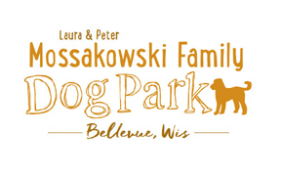

Bellevue Dog Park Meeting Agenda

September 28, 2016

12:30-2:00pm

3100 Eaton Road

Secretary Report:

Approval of July’s minutes:

Treasurer report: Account Balance:

Community Fundraising:

Next meeting: October 19 @ 12:30 at Village Hall & October 29th volunteer work day at the park 9am - lunch

New Business:
- Stephanie’s To-Do list.
- Harter’s garbage removal service.
- Porto-potti service
- Donation/fee box and its sponsorship.
- Contract change- upgrade electrical service.
- Request donation with dog license renwel.

Volunteer meetings & opportunities -

Trick-or-treat Trail -

Next steps:

Meeting adjourned:

