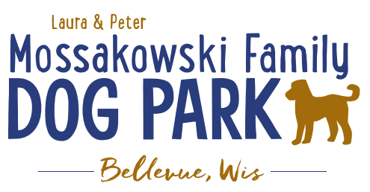
Laura and Peter Mossakowski Family Dog Park, LTD Committee Meeting

Date & Location: October 25th, 2017 @ 9:15am at Laura Mossakowski LLC (2555 Continental Dr.; Green Bay, 54311)

Meeting Began:

In attendance:

Secretary Report:
Approval of September 13th minutes:

Treasurers Report:
Current Balance:
Outstanding Bills:
Incoming Donations:
(From Sandy: The Trick Treat Trail went well. About 1300 kids came, it was busy!
Sold $63.25 at our bake sale. Note: Puppy Chow snack mix is a huge hit!
$23.44 in donations at Oak View (1 basket raffle & donations))

Community Fundraising:
Grant Writing – UPDATE on UWGB Intern
Internship description sent out to search for a UWGB student with focus on Grant-writing but also including some marketing – Title: Grant Writing and Marketing Coordinator Intern

Packers Give Back Award Nominations Submitted

Give Big Green Bay Award Submitted

Branded Items with Dog Park Logo for Fundraising
Can items be sold anywhere other than at the events? Available on website? Available at any location?

TAP grants from DOT – application for grant needs to come from the village of Bellevue or Allouez (applications start end of October) – anything further needed?

Old Business:
K9 Karnval planning to start in early 2018 – looking to fill role for a Co-coordinator

K9 Karnival – May 12th, 2018 from 10am -2pm - Josten Park vs Dog Park (Ideally at the Dog Park but primary hold up is parking if it is at the Dog Park, looking to get permission from nearby businesses for parking help)

Phase II Planning – need a closer idea / update estimates for items for future planning to help decide what will actually be in Phase II but initial thoughts include:
Water/sewer – cost to run it to park needed
Splash Pad – timed shut-off and button for turning on
Agility course/equipment – potentially donated
Water Bubbler
Further Shade Structures – another one getting donated
Other – based on available funding, estimates, and available grants

Ambassador Lanyards for Park Volunteers and / or Ambassadors

Next Meeting Date: _______________________ at Laura Mossakowski LLC (2555 Continental Dr.; Green Bay, 54311)

Construction & Maintenance Updates:
Any further work days needed? – need to stain, fertilize, plant around the fencing, mud-prone areas,
Fertilizer would need to be pet safe or a plan to make it a safe time to do it
May need post hole digger to dig in gravel area for plants

What should be looked at being done before winter? – above work day items
Purchase a few shovels for keeping at the gates for the winter?

Fence escape addressed – any further concerns?

Signs to be made for making safety concern calls accessible within the park – THANK YOU to Forever Friends for helping out with these!

New Business:
Forever Friends

Park Ambassador Vests

Park Ambassador job description/clarification

Recent Park Concerns/Problems

Outline Memorial Donation Options

Meeting Adjourned:

