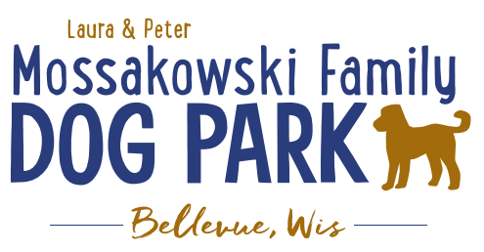
Laura and Peter Mossakowski Family Dog Park, LTD Committee Meeting
Date & Location: May 24, 2017 9:15am; at Laura Mossakowski LLC (2555 Continental Dr.; Green Bay, 54311)
Meeting Began:
In attendance:
Secretary Report:
Approval of May 10th, 2017 minutes –
Treasurers Report:
Current Balance:
Outstanding Bills:
Incoming Donations:
Community Fundraising:
Grand Opening is the major project at this time
Grant Writing – need volunteers to help (UWGB, NWTC, or other college to help with grant writing as a part of a college course/project/internship) – updates? – still looking to see if there are options for outside help
Green Bay Bullfrog Baseball Fundraiser night – two options of “packages” that are available for fundraising – (July 28th is the dog park night 7:05pm; $6 of every ticket goes to dog park and other items given out for an $18 ticket; tickets need to be sold by July 24th; Cash, check, and credit card)
Old Business:
K9 Karnival Planning: (May 13th from 10am-2pm)
Things to take away and notes to remember for next year:
Grand Opening Planning: (Tentative date June 24th; looking at a 10am start time frame)
UPDATES:
Nicole to head up the event
Thoughts on activities
- Honor Donors
- Ribbon Cutting Ceremony
- Prizes
- Let dogs play (get donated Frisbees and balls??)
Home Depot Employee Work Day Update – DATE/TIME TBD
Looking to do some plantings around right of way and around signs, maybe benches or tables, some seeding outside the fence, lunch to be provided by dog park

Additional Work Day needed shortly after K9 Karnival (tentative date: May 27th with a backup of June 3rd @ 8am) – install more trees (spruce trees and 18 from village), install message board sign, post signs, prepare park for Grand Opening, general clean up, cement slabs for benches, wrap up waste stations, lunch to be provided by donor??
Ellie Frey “Seed Money” donation: K9 Karnival, grand opening, and work day supplies to grow it to more
Kids and Dogs Safety First Program launched at K9 Karnival
Dog park submitted for community award by Stephanie
Next Meeting Dates:
Next committee meetings: June 7th 9:15am @ LMLLC; June 21st 9:15am @ LMLLC; July 5th 9:15am @ LMLLC
Construction Updates:
Still looking for nature to tell us when the grass can be mowed to allow further planning for opening dates
Needing to fertilize entire park ASAP (ideally even twice before June 24th) – first round completed
New Business:
Meeting Adjourned:
Tabled for Future Meeting:

