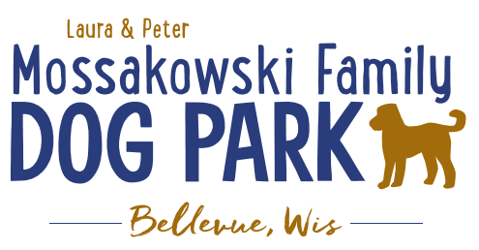
Laura and Peter Mossakowski Family Dog Park, LTD Committee Meeting
Date & Location: June 7, 2017 9:15am; at Laura Mossakowski LLC (2555 Continental Dr.; Green Bay, 54311)
Meeting Began:
In attendance:
Secretary Report:
Approval of May 24th minutes:
Treasurers Report:
Current Balance:
Outstanding Bills:
Incoming Donations:
Community Fundraising:
Grand Opening is the major project at this time
Grant Writing – need volunteers to help (UWGB, NWTC, or other college to help with grant writing as a part of a college course/project/internship) – updates? – still looking to see if there are options for outside help
Green Bay Bullfrog Baseball Fundraiser night – two options of “packages” that are available for fundraising – (July 28th is the dog park night 7:05pm; $6 of every ticket goes to dog park and other items given out for an $18 ticket; tickets need to be sold by July 24th; Cash, check, and credit card)
Old Business:
Grand Opening Planning: (Date Planned: June 24th; looking at a 10am start time)
UPDATES:
Nicole to head up the event
Thoughts on activities
- Honor Donors
- Ribbon Cutting Ceremony
- Prizes
- Let dogs play (get donated Frisbees and balls??)
Annual Pass sales booth – forms from Village, Village to have them ready to fill out and printed
Look to get some more goodies for the bags for the “VIP” donors (>$100?) – (treats, tick pullers, samples, etc.)
Check-in booth for VIP donors
Information and Volunteer booth
Home Depot Employee Work Day Update – DATE/TIME TBD
Looking to do some plantings around right of way and around signs, maybe benches or tables, some seeding outside the fence, lunch to be provided by dog park

Next Meeting Dates:
Next committee meetings: June 21st 9:15am @ LMLLC; July 5th 9:15am @ LMLLC
Construction Updates:
Still looking for nature to tell us when the grass can be mowed to allow further planning
Needing to fertilize entire park ASAP (ideally even twice before June 24th) – first round completed May 15, second to be done around June 12 (around 4:00)
New Business:
Final work time to wrap up items? (Signage, kiosk, etc.)
Volunteer E-mails – follow-up needed?
Plaque updates (memorials)
Meeting Adjourned:

