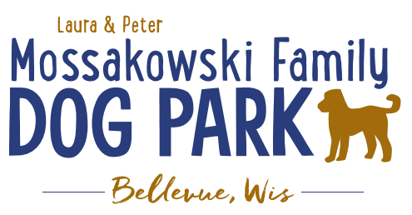
Laura and Peter Mossakowski Family Dog Park, LTD Committee Meeting
Date & Location: July 5th, 2017 9:15am; at Laura Mossakowski LLC (2555 Continental Dr.; Green Bay, 54311)
Meeting Began:
In attendance:
Secretary Report:
Approval of June 7th minutes:
Treasurers Report:
Current Balance: $
Outstanding Bills:
Incoming Donations:
Community Fundraising:
Packer Family Night Fundraiser Update – first 200 paid tickets will get them, limited to 200
Remaining ticket number:
Grant Writing – need volunteers to help (UWGB, NWTC, or other college to help with grant writing as a part of a college course/project/internship) – updates? – still looking to see if there are options for outside help
Green Bay Bullfrog Baseball Fundraiser night – two options of “packages” that are available for fundraising – (July 28th is the dog park night 7:05pm; $6 of every ticket goes to dog park and other items given out for an $18 ticket; tickets need to be sold by July 24th; Cash, check, and credit card)
Electronics Recycling Event with Cyberworks – July 8th 8-12pm – Volunteers needed to help
Old Business:
Grand Opening & K9 Karnival Final Thoughts and Wrap Up
Any remaining Thank You’s need to go out?
Home Depot Employee Work Day Update – DATE/TIME TBD
Looking to do some plantings around right of way and around signs, pathways are priority items for now, lunch to be provided by dog park

Volunteer Coordinator role needs to be filled to help with the continued management of volunteers – ideally someone committed to role to minimize turnover in the position
Next Meeting Dates:
Next committee meetings:
Construction & Maintenance Updates:
Fence Concerns
Fee box sign
New Business:
Maintenance Schedule & Sign-up (garbage pick-up, refilling bags, pick up of trash/feces around park, note maintenance needs, etc.)
Volunteerspot online sign up system
Checklist to follow?
Garbage bag supplies – who will keep them stocked?
Protocol for needed repairs – automatically done and billed to committee?, discussed at meetings first for approval and discussion/suggestion opportunity?, etc.
Kiosk postings
Our story, fundraising efforts, donor lists, etc.
Schedule additional work day for added bench pads, etc.?
Community Event Appearance (Peggy)
Fee questions – mailing stickers to those placing funds in fee box?
Meeting Adjourned:

