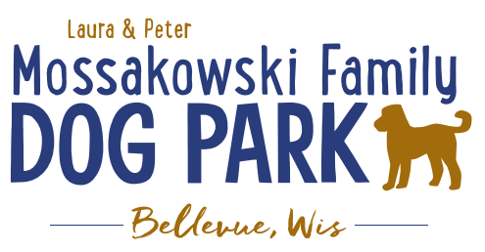
Laura and Peter Mossakowski Family Dog Park, LTD Committee Meeting
Date & Location: August 16th, 2017 9:15am; at Laura Mossakowski LLC (2555 Continental Dr.; Green Bay, 54311)
Meeting Began:
In attendance:
Secretary Report:
Approval of July 5th minutes:
Treasurers Report:
Current Balance: $
Outstanding Bills:
Incoming Donations:
Community Fundraising:
Grant Writing – need volunteers to help (UWGB, NWTC, or other college to help with grant writing as a part of a college course/project/internship) – updates? – still looking to see if there are options for outside help
Packer Night Fundraiser and Bullfrog Game Wrap-up – worth doing again?
Electronics Recycling Event Wrap-up – worth doing again?
Dog Yoga in the Park Update:
Old Business:
Home Depot Employee Work Day Update – DATE/TIME TBD
Looking to do some plantings around right of way and around signs, pathways are priority items for now, lunch to be provided by dog park (removed from agenda until further planning is made)

Volunteer Coordinator role needs to be filled to help with the continued management of volunteers – ideally someone committed to role to minimize turnover in the position
Park Steward VolunteerSpot.com progress
Kiosk updates to be made at work-day – can we get a copy of the Bellevue Beat article for in it along with other items Jennie has put together (Our story, fundraising efforts, donor lists, etc., park steward job descriptions, volunteer descriptions, maintenance check lists, sign that says bring water for your dog, master plan, future fundraising plans)
Next Meeting Dates:
Next committee meetings:
Construction & Maintenance Updates:
Parking on grass – consider a sign asking to please not park on grass?
New Business:
Work day planned for Sunday:
Added Bench Pads, silt fence, fill in under gates, fill in holes, install hydrant, bench mountings (4 - look at pre-made cement blocks?), seed around concrete slabs,
Date: Sunday, August 20th @ 8am (Lunch provided at 12:00?)
Director of Marketing position open -
Meeting Adjourned:

