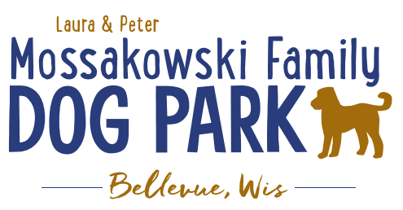
Laura and Peter Mossakowski Family Dog Park, LTD Committee Meeting
Date & Location: Sept 13, 2017 9:15am at Laura Mossakowski LLC (2555 Continental Dr.; Green Bay, 54311)
Meeting Began:
In attendance:

Secretary Report:
Approval of July 5th minutes:

Treasurers Report:
Current Balance:
Outstanding Bills:
Incoming Donations:

Community Fundraising:
Grant Writing – UPDATE on UWGB options
In short:
We could offer an internship for a semester (3 months)
The career services director would have to get the internship offer approved, as it is unpaid.
The student would need to achieve approx. 10 hours per week in work (150 total)
One of us would have to be appointed as the student’s supervisor- be accessible via phone/email and provide an evaluation at the end
The student would not be able to “renew” the internship for another semester, so we would be putting time & energy into a short term helper

Packers Grant to look to help animal related causes in 2019

Old Business:
Still in search of a Grant Writer, Volunteer Coordinator, as well as Director of Marketing – can any of the roles be combined?

Next Meeting Date: Sept 13, 2017 9:15 at Laura Mossakowski LLC (2555 Continental Dr.; Green Bay, 54311)

Construction & Maintenance Updates:
Any further work days needed?
What should be looked at being done before winter?

New Business:
Can we get a monthly update on bills that come in through the village?

Discussion of what the committee’s role is for the park (problem management, alerting village for concerns vs having visitors reach out directly, etc.)

Phase II Planning
Water/sewer
Splash Pad
Agility course/equipment
Water Bubbler
Further Shade Structures
Other

Meeting Adjourned:

