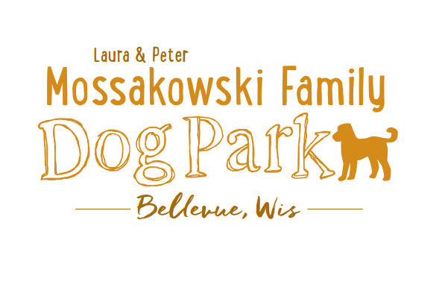
Laura and Peter Mossakowski Family Dog Park, LTD Committee Meeting
Date & Location: March 29, 2017 9:30am-11:30am; at Laura Mossakowski LLC (2555 Continental Dr.; Green Bay, 54311)
Meeting Began:
In attendance:
Secretary Report:
Approval of March 1st, 2017 minutes –
Treasurers Report:
Current Balance:
Outstanding Bills:
Incoming Donations:
Community Fundraising:
K9 Karnival and Grand Opening major projects at this time
Grant Writing – need volunteers to help (UWGB, NWTC, or other college to help with grant writing as a part of a college course/project/internship) – updates?
Old Business:
Looking at options for donor signs – many options need sign approval and will need to be uniform with other signage in the park and other parks
Membership Stickers Ordered – sales start at K9 Karnival (600 stickers ordered)
Volunteer Committee Updates: Volunteer needed to help with recruiting; no age limit, forms just ask for an adult to sign the waiver
K9 Karnival Planning: (May 13th from 10am-2pm)
Raffle items / list of donors – any additions or updates?
Volunteer Table added to Karnival Layout - include "titles/roles" that are needed (Grant writers, etc.)
MC - Alexi
Poss. Live Music
Booth coordination – Sandy
Station for credit card for Paul to be at (large sign needed)
Walkie-talkies for communication
Raffle workers - Paul, Laura, and one needed
Pictures - Jennie
Volunteer Table - Nicole
Posters/Fliers – Stephanie
Bounce House – Adam to reach out to Salvation Army
Luer Course – Mark to run it?? 3 more to help (Angela?)
Food Booth – Steve and family? And friends of Bellevue members?

Vendor Booths – Vendors should not be selling food/beverages, but is other fundraising OK?
Booth rental fee of $25, table rental fee of $10, NPO’s leave $25 deposit and can get it back upon check-in (approved 3/1/17)
Festival to join us with cart?
Look to get help with fund counting post event from the bank or others
Grand Opening Planning: Date TBD (ideally within a few weeks of K9 Karnival)
Nicole to help head up the event?
Thoughts on activities?
Home Depot Employee Work Day - Landscaping is specialty for the projects, a Grant covers the cost of the items – need walkthrough for the company before starting
Ideally a 1-day project, need to do a walk-through - looking to do project around sign and driveway and around the fence where the trash bins are - Updates

Donation Envelopes with tear-off – Stephanie looking to get options - Update

Nicole Virant nominated as Director of Marketing to the Dog Park Committee Board Feb. 1, 2017 – Acceptance needed from Nicole

*Addition of a Mission Statement for the Park – further thoughts/approval
Laura & Peter Mossakowski Family Dog Park (Bellevue Dog Park) is a volunteer-based, non-profit501(c)(3) organization. The Bellevue Dog Park Committee is dedicated to providing an off-leash dog park where dogs and their owners/friends have a safe, well-maintained area for recreation and socialization.
The Bellevue Dog Park committee will also make it their focus to educate children about safe behavior around dogs to ensure a common goal of safety and fun for all.
The Bellevue Dog Park relies on local and private funding to continue growth and development of this off-leash dog park. The committee welcomes collaboration with residents, businesses, municipalities, and non-profit groups to work toward this common goal.

Obtain Bulletin Board with plexi-glass coverings – Lions Club approved sponsorship

Child Safety Program Update (Sandy)

Next Meeting Dates:
No further VB meetings set for Dog Park related items
Next committee meeting: March 29th 9:30-11:30am – likely increasing frequency until events are planned (@LMLLC)
Construction Updates:
Still looking for nature to tell us when the grass can be mowed to allow further planning for opening dates
New Business:
Wix Memorial Update
Marketing Recruitment Ideas - Social Media plugs for upcoming events and volunteer needs (Nicole), any other thoughts/suggestions?
Volunteer Agreement – Customize it for the Dog Park
Logging options for hours for volunteering through the year - potential to earn discounts off of future passes, appreciation brunch etc. – Further Thoughts
Donation from Kathy Ploeckelmann – Trees, Concrete Bench – thoughts/suggestions?
Eagle Scout Project – Connor L. – Bench? Agility item(s)?
Additional Work Day needed?
Meeting Adjourned:

Topics for Next Meeting:

