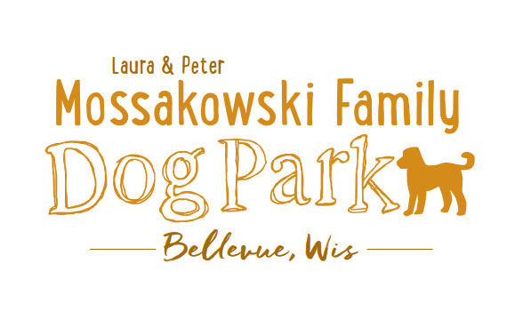Committee Meeting Agenda
November 8th, 2016
Meeting Began:

Secretary Report:
Please be sure to send the Thank You e-mails with the subject line as such,
it is difficult to find them when they are within other messages

Treasurers Report:

Community Fundraising:
Packer Grant Update

Old Business:
Great Job at the work day!!

Fees with Village Agreement - Continue to narrow down expense responsibilities

Next Meeting Dates:

New Business:
Park Rules Signs (Sandy) -

Fee schedule based on $10,000 annual maintenance budget

Meeting Adjourned:

