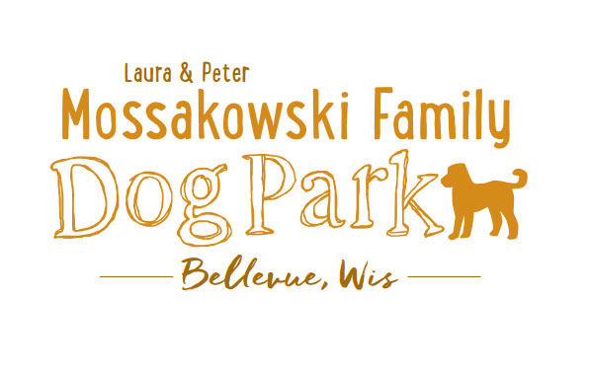
Laura and Peter Mossakowski Family Dog Park, LTD Committee Meeting
Date & Location: April 14, 2017 9 am-11 am; at Laura Mossakowski LLC (2555 Continental Dr.; Green Bay, 54311)
Meeting Began: 9:05am
In attendance: Sandy Kemper, Jennie Wertel, Peggy Grimmer, Laura Mossaskowski, Adam Waszak, Stephanie Schlag, Connor Smith, Todd Smith
Secretary Report:
Approval of March 29th, 2017 minutes – Sandy, Laura
Treasurers Report:
Current Balance: $13,127.12
Outstanding Bills: Liser and Bulletin board
Incoming Donations: few checks coming in yet from K9 Karnival
Community Fundraising:
K9 Karnival and Grand Opening major projects at this time
Grant Writing – need volunteers to help (UWGB, NWTC, or other college to help with grant writing as a part of a college course/project/internship) – updates? – still looking to see if there are options for outside help
Green Bay Bullfrog Baseball Fundraiser night – two options of “packages” that are available for fundraising – individual to take lead on it?
Old Business:
K9 Karnival Planning: (May 13th from 10am-2pm)
Raffle items / list of donors – Packer item TBD, continue to go through list for donations and raffle items, bring all raffle items to Laura’s office for assembly
Volunteer Table added to Karnival Layout - include "titles/roles" that are needed (Grant writers, etc.)
MC – Alexi
Music on device - Stephanie
Booth coordination – Sandy
Station for credit card for Paul to be at (large sign needed)
Phone list updated for communication at event
Raffle workers - Paul, Laura, and Peggy
Paw Printing Stand – Sandy
Bobbing for Balls Pool –
Pictures & Info Booth - Jennie
Volunteer Table - Nicole
Posters/Fliers – Stephanie
Bounce House – Adam to reach out to Salvation Army
Luer Course – Mark to run it with 2-3 more to help (Angela and ______)
Food Booth – Steve and family and friends of Bellevue members
Steve to see if food donations are an option from businesses
Happy Joes has been contacted and others for donations

Morning meeting at the day of the Karnival to meet all volunteers, get name tags, and see/hear job duties – Set-up starting at 8:30, brief meeting for volunteers at 9:30 under pavilion

Vendor Booths – Vendors should not be selling food/beverages, but is other fundraising OK
Mary Kay Rep willing to donate 25% of the sales if she has a booth
Forever Friends will be doing collapsible bowls
Booth rental fee of $25, table rental fee of $10, NPO’s leave $25 deposit and can get it back upon check-in
$5 donation per dog attending and 5 event tickets per family
Festival invited to join us with cart
State Bank allowing us to borrow a currency counter for the day – counting to be done at the end of the event
Annual Passes – Village is not wanting sales to take place until the Grand Opening
Grand Opening Planning: Date TBD (ideally within a few weeks of K9 Karnival)
Nicole to help head up the event
Thoughts on activities?
- Frisbie retrieval/catch contest
- Fastest return on command
Home Depot Employee Work Day Update – Looking to get proof of insurance for liability
Nicole Virant nominated as Director of Marketing to the Dog Park Committee Board Feb. 1, 2017 – Acceptance from Nicole

Eagle Scout Project – Connor L. – Update – Mulch under bench, treated wood with cover, looking to put it on the south west area of the park to keep people flowing into the park well, Village Building inspector would like to see the plan (Rodger), Sherriff’s department potentially partnering with project for Wixx memorial??,
Additional Work Day needed shortly after K9 Karnival (tentative date: May 27th with a back up of June 3rd @ 8am) – install more trees (spruce trees and 18 from village), install message board sign, post signs, prepare park for Grand Opening, general clean up, cement slabs for benches, wrap up waste stations, need port-o-potty?,
Addition of a Mission Statement for the Park – further thoughts/approval
Laura & Peter Mossakowski Family Dog Park (Bellevue Dog Park) is a volunteer-based, non-profit501(c)(3) organization. The Bellevue Dog Park Committee is dedicated to providing an off-leash dog park where dogs and their owners/friends have a safe, well-maintained area for recreation and socialization.
The Bellevue Dog Park committee will also make it their focus to educate children about safe behavior around dogs to ensure a common goal of safety and fun for all.
The Bellevue Dog Park relies on local and private funding to continue growth and development of this off-leash dog park. The committee welcomes collaboration with residents, businesses, municipalities, and non-profit groups to work toward this common goal.

Child Safety Program Update (Sandy)

Marketing Recruitment Ideas - Social Media plugs for upcoming events and volunteer needs, any other thoughts/suggestions?
Next Meeting Dates:
No further VB meetings set for Dog Park related items
Next committee meetings: April 14th 9am @ LMLLC; April 26th 9:15am @ LMLLC; May 10th 9:15am @ LMLLC
Construction Updates:
Still looking for nature to tell us when the grass can be mowed to allow further planning for opening dates
New Business:
Wix Memorial Update – partnering with Connor’s Project??
Allouez Farmers Market Booth – Paul helping to facilitate it
Mowing of the park addressed with Village
Try to make a decision about park availability months – open for Winter?
Meeting Adjourned: 10:50am

Topics for Future Meetings:
Memorial Bench standard options and costs for those interested in donation
Kathy Ploeckelmann Donations – trees and concrete bench
Donation envelopes – Stephanie Working on
Signage plans and options based on village requirements
Volunteer waiver – customize it for the park
Logging options for volunteers – options for recognition for time spent volunteering?
Volunteer Committee Update

