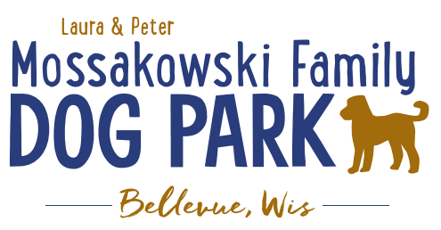
Laura and Peter Mossakowski Family Dog Park, LTD Committee Meeting
Date & Location: June 7, 2017 9:15am; at Laura Mossakowski LLC (2555 Continental Dr.; Green Bay, 54311)
Meeting Began: 9:20am
In attendance: Laura Mossakowski, Peggy Grimmer, Paul Theys, Sandy Kemper, Donn Foote, Stephanie Schlag, Jennie Wertel
Secretary Report:
Approval of May 24th minutes: Sandy, Paul
Treasurers Report:
Current Balance: $15,464
Outstanding Bills: Lizer Landscaping ($8500), shade structure
Incoming Donations: $170 on “Seed Money” card
Community Fundraising:
Grand Opening is the major project at this time
Grant Writing – need volunteers to help (UWGB, NWTC, or other college to help with grant writing as a part of a college course/project/internship) – updates? – still looking to see if there are options for outside help
Green Bay Bullfrog Baseball Fundraiser night – two options of “packages” that are available for fundraising – (July 28th is the dog park night 7:05pm; $6 of every ticket goes to dog park and other items given out for an $18 ticket; tickets need to be sold by July 24th; Cash, check, and credit card)
Old Business:
Grand Opening Planning: (Date Planned: June 24th; looking at a 10am start time)
UPDATES:
Nicole to head up the event
Thoughts on activities
- Honor Donors and special guests
  - Just before ribbon cutting ceremony
- Ribbon Cutting Ceremony @10am
  - Scissors – ask village to borrow from the Bellevue Business Professionals
- Prizes
  - Sandy collected items to get them to Nicole
- Let dogs play (get donated Frisbees and balls??)
  - Festival donated Frisbees and have balls for dogs
Annual Pass sales booth – forms from Village, Village to have them ready to fill out and printed
Village to bring stickers they have to be able to hand them out
Money Bags/boxes needed at booth
Change needed to start day
Look to get some more goodies for the bags for the “VIP” donors (>$100?) – (treats, tick pullers, samples, etc.)
Check-in booth for VIP donors
Invites sent for VIP donors
Information and Volunteer booth (have Bullfrog game info too)
Forever Friends to bring more collapsible bowls
Village to provide speakers and microphone equipment
Provide water at the event for dogs – donated? (Konopp, Culligan, etc. – dogs are priority but if bottles for humans available that would be helpful too)
Bring coolers with ice to be able to sell water as fundraiser
Home Depot Employee Work Day Update – DATE/TIME TBD
Looking to do some plantings around right of way and around signs, pathways are priority items for now, lunch to be provided by dog park

Next Meeting Dates:
Next committee meetings: June 21st 9:15am @ LMLLC; July 5th 9:15am @ LMLLC
Construction Updates:
Still looking for nature to tell us when the grass can be mowed to allow further planning – 1 mowing done and another scheduled to be done this week
Needing to fertilize entire park ASAP (ideally even twice before June 24th) – first round completed May 15, second to be done around June 12 (around 4:00pm)
New Business:
Final work time to wrap up items needed? (Signage, kiosk, etc.) – Village is finishing the signs and kiosk, benches to be installed by company, shade structure to be done by company, picnic tables to be done week before (date/time TBD), fix ruts made by concrete truck
Items in Kiosk – fundraising efforts, donors, etc. for now
Volunteer E-mails – follow-up needed for filling roles, social media push and PR coverage for volunteers, Volunteer Coordinator role needs to be filled to help with the continued management of volunteers
Plaque updates (memorials) – quoted $20 for one for the hydrant and one for the bench
Meeting Adjourned: 10:30am

