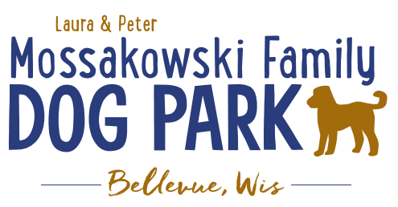
Laura and Peter Mossakowski Family Dog Park, LTD Committee Meeting
Date & Location: July 5th, 2017 9:15am; at Laura Mossakowski LLC (2555 Continental Dr.; Green Bay, 54311)
Meeting Began: 9:15am
In attendance: Sandy Kemper, Connor Smith, Todd Smith, Paul Theys, Mark Schuster, Jennie Wertel, Laura Mossakowski, Peggy Grimmer, Stephanie Schlag
Secretary Report:
Approval of June 7th minutes: Sandy, Paul
Treasurers Report:
Current Balance: $14,363
Outstanding Bills: $8,000 to Lizer and $5000 for shade structure
Incoming Donations: Packer family night ticket sales, etc.
Community Fundraising:
Packer Family Night Fundraiser Update – first 200 paid tickets will get them, limited to 200
Remaining ticket number: 0!
Grant Writing – need volunteers to help (UWGB, NWTC, or other college to help with grant writing as a part of a college course/project/internship) – updates? – still looking to see if there are options for outside help
Green Bay Bullfrog Baseball Fundraiser night – two options of “packages” that are available for fundraising – (July 28th is the dog park night 7:05pm; $6 of every ticket goes to dog park and other items given out for an $18 ticket; tickets need to be sold by July 24th; Cash, check, and credit card) – Refresh on Social Media
Electronics Recycling Event with Cyberworks – July 8th 8-12pm – Volunteers needed to help
Put out push for individuals to host dog yoga classes at the park on Saturday/Sunday mornings? - Nicole to reach out on Social Media
Old Business:
Grand Opening & K9 Karnival Final Thoughts and Wrap Up
Any remaining Thank You’s need to go out? – all wrapped up
Home Depot Employee Work Day Update – DATE/TIME TBD (still looking to find new coordinator with HD)
Looking to do some plantings around right of way and around signs, plantings around screen structure, pathways are priority items for now, lunch to be provided by dog park

Volunteer Coordinator role needs to be filled to help with the continued management of volunteers – ideally someone committed to role to minimize turnover in the position
Next Meeting Dates:
Next committee meetings: Wednesday, August 16th @ 9:15am (@LMLLC)
Construction & Maintenance Updates:
Fence Concerns – address on workday
Gate Gap Fill In – fill in under gates with top soil to help reduce gaps and seed it
Fee box sign – village to order it and install it above fee box to clarify
Silt fence removal and DNR approval for finishing up
New Business:
Maintenance Schedule & Sign-up (garbage pick-up, refilling bags, pick up of trash/feces around park, note maintenance needs, etc.)
Volunteerspot online sign up system – some issues with some log in, looking to send another request
Checklist to follow – see park steward role
Garbage bag supplies – village to keep them stocked in the bottom of the bins
Feces bag supplies – first 2000 supplied by Oakvew Animal Hospital
Protocol for needed repairs – some case by case and urgency needs,
Kiosk postings
Our story, fundraising efforts, donor lists, etc. – park steward job descriptions, volunteer descriptions, maintenance check lists, sign that says bring water for your dog, master plan, future fundraising plans
Schedule additional work day for added bench pads, etc. – silt fence, fill in under gates, fill in holes (drain tile??), install hydrant, bench mountings (4), seed around concrete slabs, look at pre-made cement blocks
Tentative date: Sunday, August 20th @ 8/9am
Community Event Appearance (Peggy) – Community Kids Safe Block Party planned, would we want to have a booth? August 12 from 10am-3pm @ Self Defense Ctr on Packerland
Fee questions – mailing stickers to those placing funds in fee box, stickers to be placed on tags (instructions in multiple places now)
Meeting Adjourned: 10:30am

