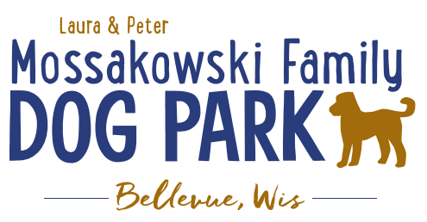
Laura and Peter Mossakowski Family Dog Park, LTD Committee Meeting
Date & Location: August 16th, 2017 9:15am; at Laura Mossakowski LLC (2555 Continental Dr.; Green Bay, 54311)
Meeting Began: 9:20AM
In attendance: Laura Mossakowki, Paul Theys, Sandy Kemper, Mark Schuster, Stephanie Schlag, Connor Smith, & Todd Smith
Secretary Report: Approval of July 5th minutes: Laura & Paul approved
Treasurers Report:
Current Balance: $15,727.17 $107.00 remaining on gift card
Outstanding Bills: $7500.00 Lizer $5000.00 Shade Structure
Incoming Donations: $400 from private donor
$200 from electronics recycling event
$1000 from Margaritas
Community Fundraising:
- Grant Writing – need volunteers to help (UWGB, NWTC, or other college to help with grant writing as a part of a college course/project/internship) – updates? – still looking to see if there are options for outside help
No one has stepped forward.
- Packer Night Fundraiser and Bullfrog Game Wrap-up – worth doing again?
Packer night ticket sales brought in $800.00- Yes, will do again!
- Bullfrog night- Have not heard or received a check from Bullfrogs yet
- Electronics Recycling Event Wrap-up – worth doing again? Not really
- Dog Yoga in the Park Update: No yoga instructors volunteered. Table this idea for next year.

Old Business:
- Volunteer Coordinator role needs to be filled to help with the continued management of volunteers – ideally someone committed to role to minimize turnover in the position- Sandy is managing volunteer sign ups right now.
- Park Steward VolunteerSpot.com progress-making progress, Sandy is inviting weekly. Getting more sign ups.
- Kiosk updates to be made at work-day – can we get a copy of the Bellevue Beat article for in it along with other items Jennie has put together (Our story, fundraising efforts, donor lists, etc., park steward job descriptions, volunteer descriptions, maintenance check lists, sign that says bring water for your dog, master plan, future fundraising plans)
- Home Depot is not coming through with their community contribution due to high staff turnover.

- Next Meeting Date: Sept 13, 2017 9:15 at Laura Mossakowski LLC (2555 Continental Dr.; Green Bay, 54311)

- Construction & Maintenance Updates:
Parking on grass – consider a sign asking to please not park on grass? Per Stephanie, not at this time.
Stephanie does recommend that we cement in the barrier posts that protect the light posts from getting hit.
We discussed staining the wood screen by the port-a-jon.

New Business:
- Stephanie reports that the village has sold over 200 annual passes. We will receive statements and invoices twice annually in July and December with complete information.

- We will ask Molly Schuster for advice on plants/shrubs by the sign.

- Work day planned for Sunday: 9:00am Sunday August 20, 2017
Stephanie will arrange for mulch delivery.
Main project is removing the silt fencing and will have to find a source for disposal.
Fill in gaps under gates w/ skid steer, clear
Paul will get grass seed & fertilizer.
Install hydrant- Mark will do.
Paul will pick up concrete slabs & plan to fasten the benches to slabs.
Gravel Path- maybe will be installed on this day? Need 2 skid steers. Paul will call Peters or Crop Trucking to order 20yds gravel.
We will put stones or mulch in the flower bed by the sign
Date: Sunday, August 20th @ 8am (Lunch provided at 12:00)

- Director of Marketing position open –still in search

- The Packers will focus 2019 will be an animal related fundraising.

- September meeting will focus on Phase II- i.e. water/sewer, doggie splash pad, agility course, doggie & human bubbler. etc.

Meeting Adjourned: 10:30am

Respectfully submitted,
Sandy Kemper
Mossakowski Family Dog Park-Vice President

