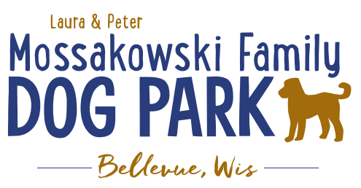
Laura and Peter Mossakowski Family Dog Park, LTD Committee Meeting
Date & Location: Sept 13, 2017 9:15am at Laura Mossakowski LLC (2555 Continental Dr.; Green Bay, 54311)
Meeting Began: 9:25am
In attendance: Toni McBride, Mark Schuster, Laura Mossakowski, Paul Theys, Sandy Kemper, Jennie Wertel

Secretary Report:
Approval of July 5th minutes: (Paul, Sandy)

Treasurers Report:
Current Balance: $10,080, gift card still has funds on it
Outstanding Bills: $301 for gravel, shade structure paid and Lizer paid but still some outstanding, second shade structure but it will be covered by a donor
Incoming Donations: gravel donor, Cyberworks fundraiser, etc. still incoming from the last meeting

Community Fundraising:
Grant Writing – UPDATE on UWGB options
In short:
We could offer an internship for a semester (3 months)
The career services director would have to get the internship offer approved, as it is unpaid.
The student would need to achieve approx. 10 hours per week in work (150 total)
One of us would have to be appointed as the student’s supervisor- be accessible via phone/email and provide an evaluation at the end
The student would not be able to “renew” the internship for another semester, so we would be putting time & energy into a short term helper
Job description – Grant writing, social media, and other volunteer opportunities (paw print campaign, go fund me campaigns for smaller additions to the park).

Packers Grant to look to help animal related causes in 2019

Packers Give Back Award Nominations

Look at getting branded items to sell – water carriers, coffee mugs, ball chuckers, shirts, etc. to sell at events

TAP grants from DOT – application for grant needs to come from the village of Bellevue or Allouez (applications start end of October)

Old Business:
Still in search of a Grant Writer, Volunteer Coordinator, as well as Director of Marketing – can any of the roles be combined? – Intern Title – Marketing and Grant Writing Coordinator

Next Meeting Date: October 25th, 2017 @ 9:15am at Laura Mossakowski LLC (2555 Continental Dr.; Green Bay, 54311)

Construction & Maintenance Updates:
Any further work days needed? – need to stain, fertilize, plant around the fencing, mud-prone areas,
Fertilizer would need to be pet safe or a plan to make it a safe time to do it
Date TBD at October meeting if needed
May need post hole digger to dig in gravel area
What should be looked at being done before winter? – above work day items
Purchase a few shovels for keeping at the gates for the winter?
Additional shade structure in the large dog area – towards the South end corner

Fence escape routes to be addressed – add some fence extensions to the base of the fence in low areas

Signs to be made for making safety concern calls accessible within the park

New Business:
Can we get a monthly update on bills that come in through the village? – a statement can be sent out at the end of June and again at the end of the year from the village
Monthly updates on annual pass sales so that we can keep up with the maintenance and know what bills may be coming in that need to be covered outside of that

Discussion of what the committee’s role is for the park (problem management, alerting village for concerns vs having visitors reach out directly, etc.)
Look for areas under the fence and report it to the Parks Department
Park Concerns to Stephanie
Safety Concerns to Sherriff’s office
Put together a standard e-mail response to outline who to contact and how action can be taken

Phase II Planning – need a closer idea / update estimates for items for future planning to help decide what will actually be in Phase II
Water/sewer – cost to run it?
Splash Pad – timed shut-off and button for turning on
Agility course/equipment – potentially donated?
Water Bubbler
Further Shade Structures – another one getting donated
Other – based on available funding, estimates, and available grants

Toni interested in fundraising, some marketing and events

K9 Karnival – May 12th, 2018 from 10am -2pm – discussion of Josten Park vs Dog Park (primary hold up is parking if it is at the Dog Park).
Looking for an event Coordinator Partner to help

Meeting Adjourned: 11:15am

