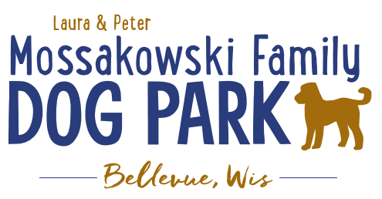
Laura and Peter Mossakowski Family Dog Park, LTD Committee Meeting
Date & Location: June 21, 2017 9:15am; at Laura Mossakowski LLC (2555 Continental Dr.; Green Bay, 54311)
Meeting Began:
In attendance: Donn Foote, Stephanie Schlag, Peggy Grimmer, Laura Mossakowski, Paul Theys, Jennie Wertel
Secretary Report:
Approval of June 7th minutes: Paul, Jennie
Treasurers Report:
Current Balance: $14,698.11
Outstanding Bills: Lizer still owed $8000
Incoming Donations:
Community Fundraising:
Grand Opening is the major project at this time
Packer Family Night Fundraiser Update – first 200 paid tickets will get them, limited to 200
Grant Writing – need volunteers to help (UWGB, NWTC, or other college to help with grant writing as a part of a college course/project/internship) – updates? – still looking to see if there are options for outside help
Green Bay Bullfrog Baseball Fundraiser night – two options of “packages” that are available for fundraising – (July 28th is the dog park night 7:05pm; $6 of every ticket goes to dog park and other items given out for an $18 ticket; tickets need to be sold by July 24th; Cash, check, and credit card)
Electronics Recycling Event with Cyberworks – July 8th 8-12pm – Volunteers needed to help
Old Business:
Grand Opening Planning: (Date Planned: June 24th; looking at a 10am start time)
Set up starting at 9am
UPDATES:
Nicole to head up the event
Thoughts on activities
Set up the ribbon cutting and few tables at the entrance of the park then allow everyone to get into the park and enjoy it
- Honor Donors and special guests
  - Just before ribbon cutting ceremony
- Ribbon Cutting Ceremony @10am
  - Scissors – ask village to borrow from the Bellevue Business Professionals
- Prizes
  - Sandy collected items to get them to Nicole
- Let dogs play (get donated Frisbees and balls??)
  - Festival donated Frisbees and have balls for dogs
Stephanie to contact for press release
Annual Pass sales booth – forms from Village, Village to have them ready to fill out and printed
Village to bring stickers they have to be able to hand them out
Money Bags/boxes needed at booth
Change needed to start day
Look to get some more goodies for the bags for the “VIP” donors (>$100?) – (treats, tick pullers, samples, etc.)
Check-in booth for VIP donors
Invites to be sent for VIP donors
Information and Volunteer booth (have Bullfrog game info too)
Forever Friends to bring more collapsible bowls
Village to provide speakers and microphone equipment
Bring coolers with ice to be able to sell water as fundraiser
Home Depot Employee Work Day Update – DATE/TIME TBD
Looking to do some plantings around right of way and around signs, pathways are priority items for now, lunch to be provided by dog park

Additional work day needed for 4 bench pads etc.
Items in Kiosk – fundraising efforts, donors, etc. for now
Volunteer Coordinator role needs to be filled to help with the continued management of volunteers – ideally someone committed to role to minimize turnover in the position
Look to get a maintenance schedule together for volunteers – garbage pick-up, bag refills, check list, pick up of trash/feces, etc.,
Next Meeting Dates:
Next committee meetings: July 5th 9:15am @ LMLLC
Construction Updates:
Still looking for nature to tell us when the grass can be mowed to allow further planning
Fertilization done twice thus far
New Business:
Installation of signage done by village – suggested some being two sided so they are better seen
Meeting Adjourned: 10:30am

